**CHRIST (Deemed to be University)**

**Department of Computer Science**

**MSc – Artificial Intelligence and Machine Learning**

**Name:** Syed Mohammed Luqmaan (2448552)

**Course:** Java Lab

**Lab Experiment: CIA – 2**

**QUESTION 1:**

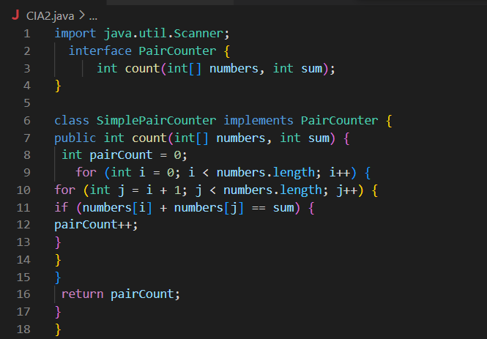

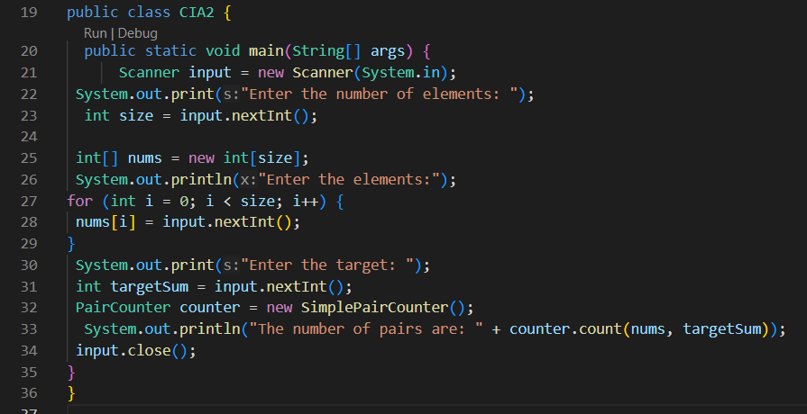

**OUTPUT:**

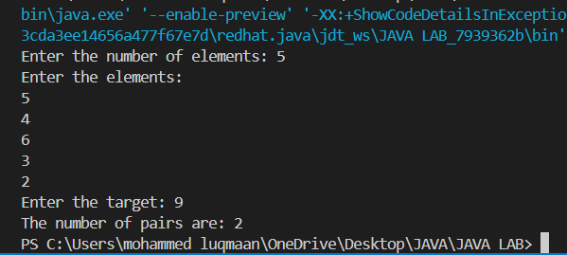

**QUESTION 2:**

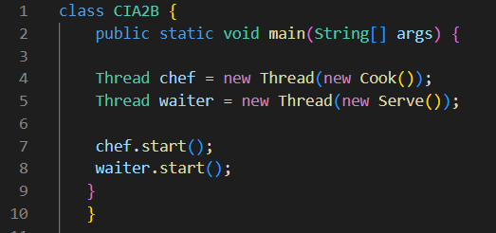

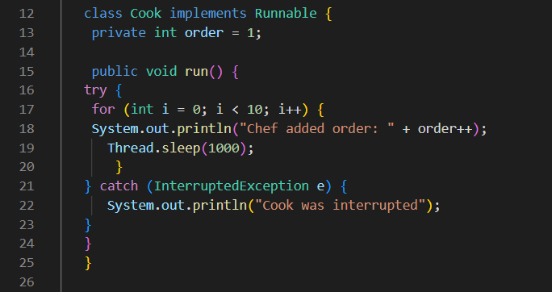

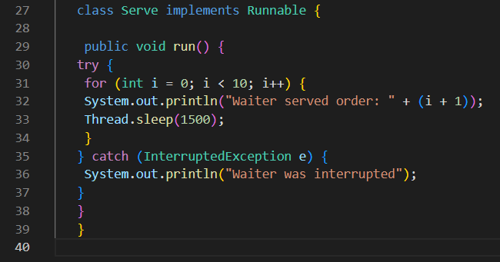

**OUTPUT:**

